
SECURITY TEST REPORT
Subject: | Security test of CyberStepsVuln web application
Period: | 2026-06-15 – 2026-06-29
Location: | Syke, Germany
Auditor: | Robin Reinhardt
Version: | 0.2

Change History
Document date | Version | Change description
2026-06-27 | 0.1 | The initial version (draft).
2026-06-28 | 0.2 | Findings Table ordered by CVSS Score

Table of Contents
1.0 Executive Summary 1
1.1 Overview 1
1.2 High-Level Test Outcomes 1
1.3 Vulnerabilities’ Risk Classification 1
1.4 Prioritized Recommendations 2
2.0 Web Application - Vulnerabilities 3
2.1 Scope 4
2.2 Summary of findings 4
2.3 Detailed findings 4

1.0 Executive Summary

1.1 Overview
This documents is a summary of work conducted by Very Good Company. The subject was a web application “CyberStepsVuln” (http://10.10.10.10)
The most severe vulnerabilities indentified during the assessment were:
- A
- B
Due to find a lot of broken access control vulnerabilities across whole application, it is recommended to perform forensic actions to check if those vulnerabilities were used in past by third party.
Report is the results of audit carried out in the best-effort method within 11 business days. The carried-out audit does not guarantee or constitute a security certificate of system safety which is the results of the scope and mode of conducted works.
During the tests, particular emphasis was placed on vulnerabilities that might affect confidentiality, integrity or availability of processed data in a negative way.
The security tests were carried out in accordance with generally accepted methodologies, including: OWASP TOP10, OWASP ASVS 3.0.1 (in a selected range) as well as internal good practices of conducting security tests developed by Very Good Company.
As a part of the testing, an approach based on manual tests (using the above-mentioned methodologies) was used, supported by a number of automatic tools, i.a. Burp Suite Community, ffuf, wpscan.
The vulnerabilities are described in detail in further parts of the report.

1.2 High-Level Test Outcomes
Ut velit mauris, egestas sed, gravida nec, ornare ut, mi. Aenean ut orci vel massa suscipit pulvinar. Donec adipiscing. Morbi in ipsum sit amet pede feugiat blandit. Curabitur gravida dapibus ipsum. Praesent blandit dolor. Sed non quam. In vel mi sit amet augue congue elementum. Morbi in lectus quis justo pulvinar ullamcorper. Pellentesque nibh. Donec est. Vivamus in. Mauris at mauris a ipsum. Donec ullamcorper, felis non sodales feugiat, libero arcu rutrum ligula, varius dictum nulla justo non est. Aenean ut eros et nisl sagittis vestibulum. Nullam nulla eros, ultricies sit amet, nonummy id, imperdiet feugiat, pede. Sed lectus. Donec mollis hendrerit risus. Phasellus nec sem in justo pellentesque facilisis. Etiam imperdiet imperdiet orci. Nunc nec neque. Phasellus leo dolor, tempus non, auctor et, placerat ac, ipsum.

1.3 Vulnerabilities’ Risk Classification
Vulnerabilities are classified in a five-point scale reflecting both the probability of exploitation of the vulnerability and the business risk of its exploitation. Below is a short description of meaning of each of severity levels.
- CRITICAL - Exploitation of the vulnerability makes it possible to compromise the server or network device, or makes it possible to access (in read and/or write mode) to data with a high degree of confidentiality and significance. The exploitation is usually straightforward, i.e. the attacker need not gain access to systems that are difficult to achieve and need not perform any kind of social engineering. Vulnerabilities marked CRITICAL must be fixed without delay, especially if they occur in production environment.
- HIGH - Exploitation of the vulnerability makes it possible to access sensitive data (similar to CRITICAL level), however the prerequisites for the attack (e.g. possession of a user account in an internal system) makes it slightly less likely. Alternatively: the vulnerability is easy to exploit but the effects are somehow limited
- MEDIUM -Exploitation of the vulnerability might depend on external factors (e.g. convincing the user to click on a hyperlink) or other conditions that are difficult to achieve. Furthermore, exploitation of the vulnerability usually allows access only to a limited set of data or to data of a lesser degree of significance.
- LOW - The exploitation of the vulnerability results in little direct impact on the security of the application or depends on conditions that are very difficult to achieve practically (e.g. physical access to the server).
- INFO - Issues marked as INFO are not security vulnerabilities per se. They aim to point out good practices, whose implementation will result in increase of general security level of the system. Alternatively: the issues point out some solutions in the system (e.g. from an architectural perspective) that might limit the negative effects of other vulnerabilities.
Below, a statistical overview of vulnerabilities is shown.

1.4 Prioritized Recommendations
Duis aute irure dolor in reprehenderit in voluptate velit esse cillum dolore eu fugiat nulla pariatur. Excepteur sint occaecat cupidatat non proident, sunt in culpa qui officia deserunt mollit anim id est laborum. Sed ut perspiciatis unde omnis iste natus error sit voluptatem accusantium doloremque laudantium, totem rem aperiam. Eaque ipsa q

2.0 Web Application - Vulnerabilities

2.1 Scope
The scope of this assessment covered the web application “CyberStepsVuln” (http://10.10.10.10) running on the provided virtual machine. All accessible functions and portals of the application were tested. No explicit restrictions were specified regarding the depth or methodology of the testing; the assessment was limited exclusively to the specified target system. Tests of the underlying infrastructure outside the application were not part of the scope.
- Target system: “CyberStepsVuln” (http://10.10.10.10)
- Test type: Black-Box
- Testing period: 2026-06-15 – 2026-06-29
- Out of scope: Denial-of-Service (DoS), social engineering, physical access, underlying host operating system / infrastructure

2.2 Summary of findings
# | Title | Severity | CVSS | Affected Component
1 | SQL Injection (Unauthenticated) | Critical | 9.8 | /visiter-newsdesk.php (param id)
2 | Privilege Escalation via Cookie Manipulation | High | 8.7 | auth_token / uid on /dashboard/
3 | Path Traversal / Arbitrary File Read | High | 7.5 | ThemeLoader.php (param theme)
4 | Hardcoded Credentials in HTML Comments | High | 7.5 | /dashboard/
5 | Broken Access Control via Forced Browsing | High | 7.5
6 | Exposure of Plaintext Password List | High | 7.5
7 | Reflected Cross-Site Scripting (XSS) | Medium | 6.1
8 | Unrestricted File Upload | Medium | 5.4
9 | Business Logic Flaw — Client-Controlled Pricing | Medium | 5.3
10 | Over-Privileged Database Account | Medium | 5.0 | DB connection config
11 | Sensitive Credentials Transmitted via GET | Medium | 3.7 | Admin.php (params Email, Password)
12 | Directory Listing Enabled | Low | 3.7

2.3 Detailed findings

2.3.1 Credendials in HTML Comments
Severity: High
CVSS 3.1: 7.5 — CVSS:3.1/AV:N/AC:L/PR:N/UI:N/S:U/C:H/I:N/A:N
CWE: CWE-615 (Information Exposure Through Comments)
Affected Component: http://10.10.10.10/dashboard (dashboard.html) — valid credentials disclosed within an HTML comment in the page source
Description: The login page served at /dashboard contains valid guest account credentials inside an HTML comment. Any unauthenticated user can view the page source and extract working credentials, bypassing the intended authentication barrier.
Proof of Concept:
- Navigate to http://10.10.10.10/dashboard
- Open the page source (Ctrl+U) / view via Burp
- Locate the HTML comment containing the credentials (Screenshot)
- Log in with the disclosed guest credentials → valid session cookie issued (Screenshot)

Remediation: Remove the credentials from the HTML comment in dashboard.html. Rotate/disable the exposed guest account. Establish a process/code-review step to prevent secrets in source comments (e.g. pre-commit secret scanning).

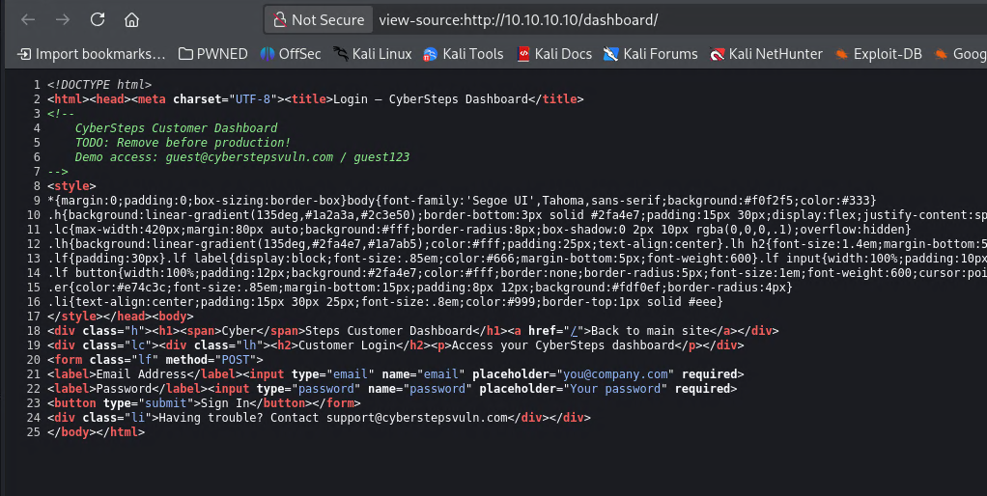

At vero eos et accusamus et iusto odio dignissimos ducimus qui blanditiis praesentium voluptatum deleniti atque corrupti quos dolores et quas molestias excepturi sint occaecati cupiditate non provident, similique sunt in culpa qui officia deserunt mollitia animi, id est laborum et dolorum fuga. Et harum quidem rerum facilis est et expedita distinctio. Nam libero tempore, cum soluta nobis est eligendi optio cumque nihil impedit quo minus id quod maxime placeat facere possimus, omnis voluptas assumenda est, omnis dolor repellendus. Temporibus autem quibusdam et aut officiis debitis aut rerum necessitatibus saepe eveniet ut et voluptates repudiandae sint et molestiae non recusandae. Itaque earum rerum hic tenetur a sapiente delectus, ut aut
consequuntur magni dolores eos qui ratione voluptatem sequi nesciunt. Neque porro quisquam est, qui dolorem ipsum quia dolor sit amet, consectetur, adipisci velit, sed quia non numquam eius modi tempora incidunt ut labore et dolore magnam aliquam quaerat voluptatem.

